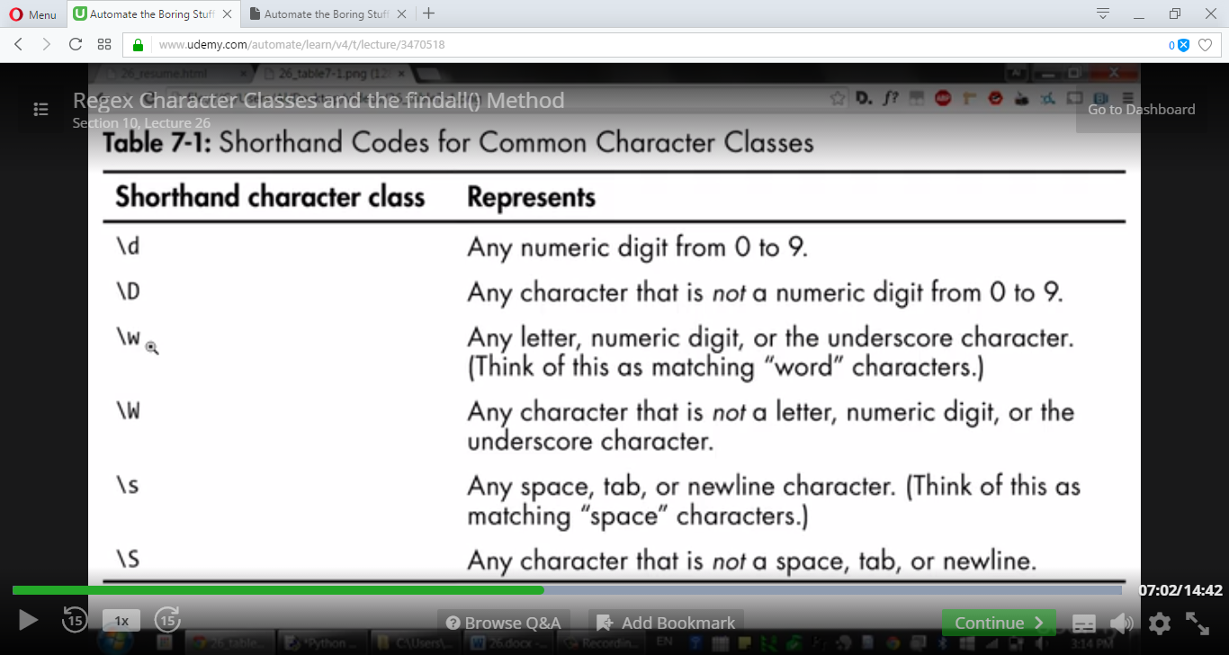

**# identify 3 character digits and next 3 characters not a digits**

import re

st = 'raju123j@eevankumar468992ramu'

reobj = re.compile('\d\d\d\D\D\D')

print(reobj.search(st))

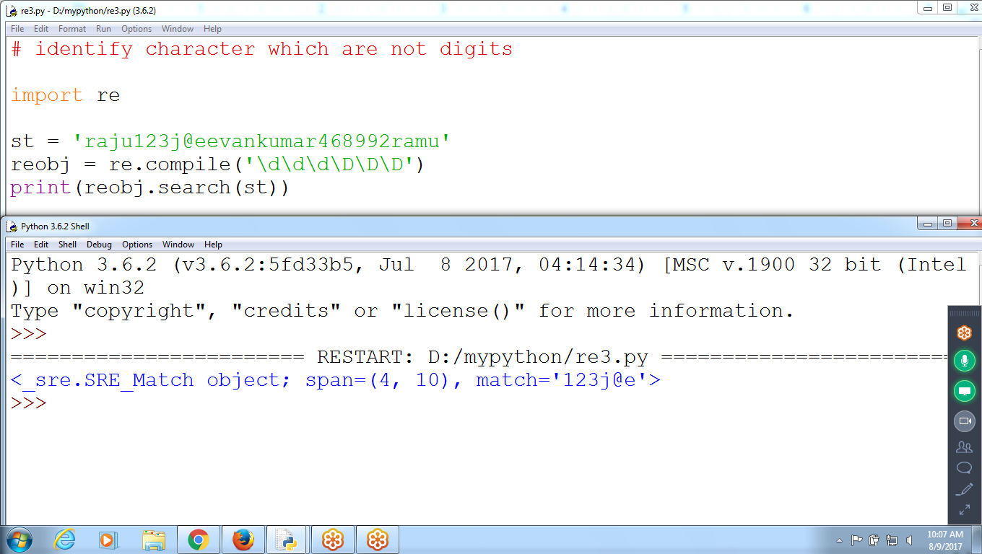

**# \w : Any character, digit or Underscore**

**# \W : NOt a character, Not a digit or Not a Underscore**

import re

st = 'r_72_raniju123j@2e_&!(vankumar468992ramu'

reobj = re.compile('\w\w\w\W\W\W')

print(reobj.search(st))

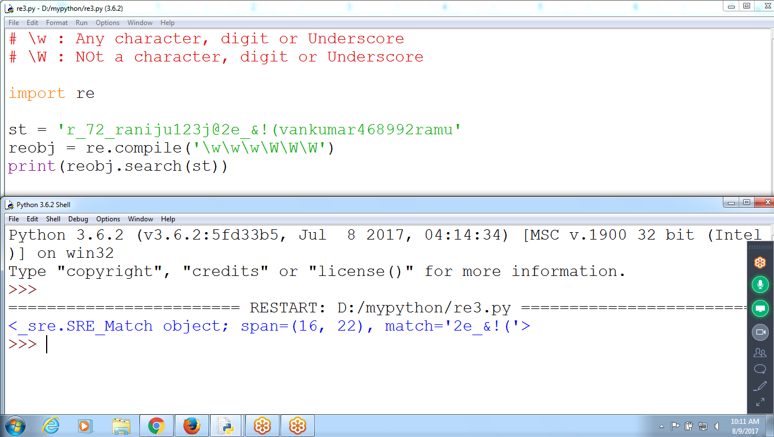

>>> reobj = re.compile(r'**\D**') **# Except Digits**

>>> st = '987689'

>>> reobj.search(st)

>>>

>>>

>>>

>>>

>>>

>>> st = '9789*abc78'

>>> reobj.search(st)

<_sre.SRE_Match object; span=(4, 5), match='*'>

>>>

**17) Pattern Matching with Digits, Spaces and Words**

**\d+ : Any number of digits**

**\s : Space(or)Tab or new line**

**\w+ : Any number of characters (alphabet, digit and underscore) :: Space not included**

? zero and one

* Zero or more

* One or more

**import re**

st ='''12 December month christmas 11 November 10 October diwali

9 September dussera 8 August indepence 7 july college reopens

6 June vacations completed 5 May summer started 4 April Exams

3 March Preparation starts 2 February cricket starts 1 January New Year '''

**reobj =re.compile('\d+\s\w+')**

**print(reobj.search(st))**

**print(reobj.findall(st))**

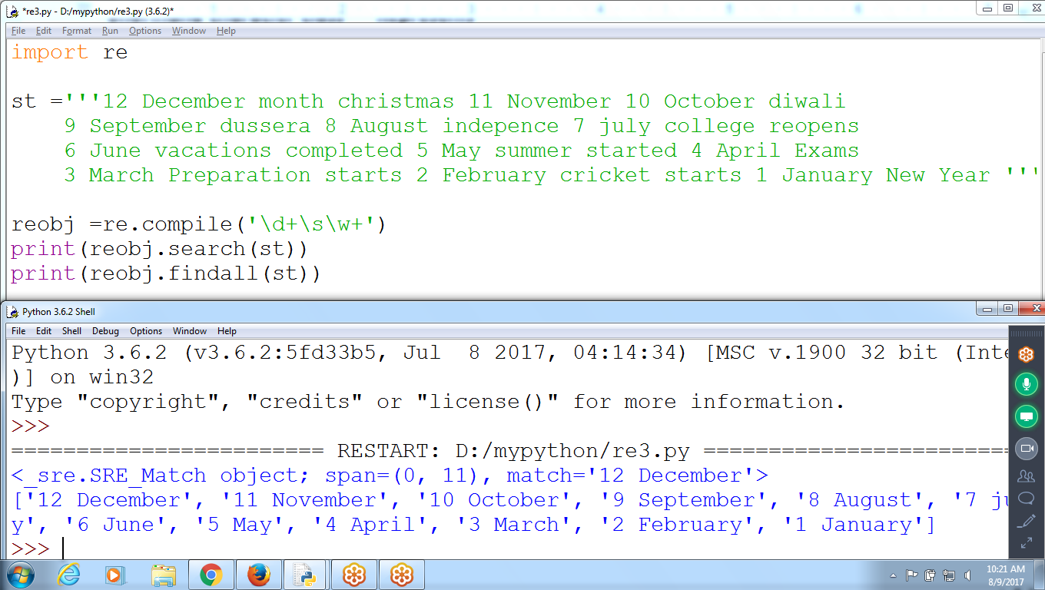

**18) ONly Vowels using [ ] i.e any one character**

**# Identify Vowels**

import re

st = ' I am using Umbrella As it is Raining '

reobj = re.compile('[aeiou]')

print(reobj.search(st))

print(reobj.findall(st))

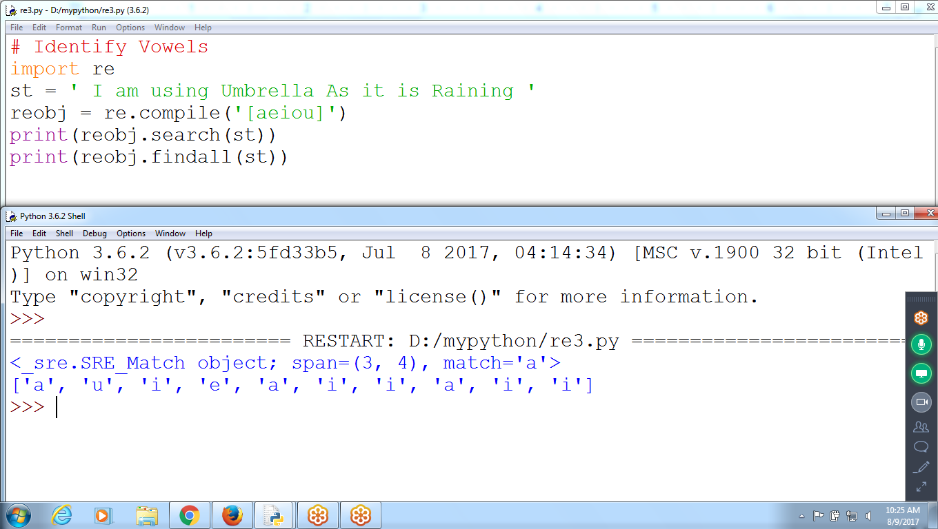

**Using Pipe |**

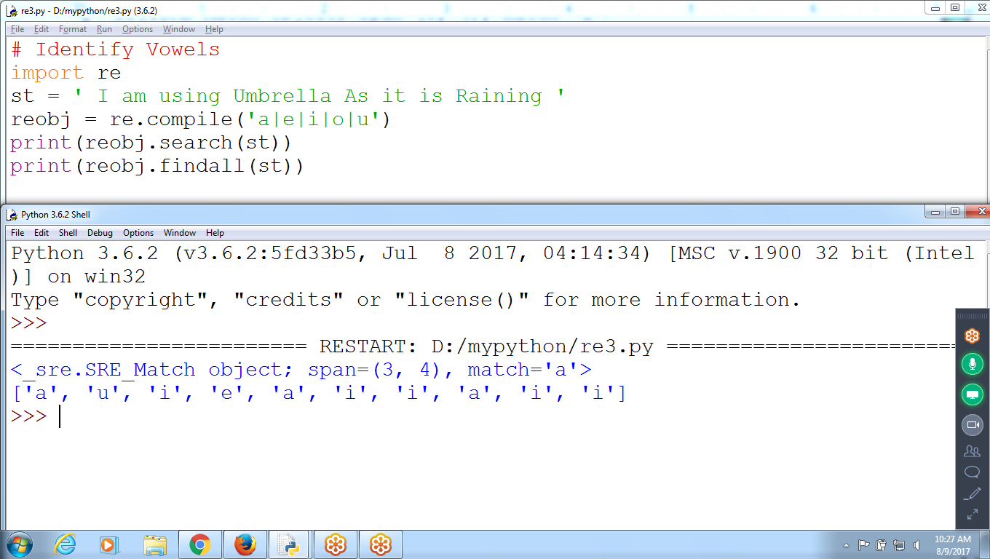

**CHecking for VOWELS aeiou**

**# Identify Vowels Combination of 2 characters**

import re

st = ' Iam using UmbrellaAs it is Raining '

reobj = re.compile('[aeiouAEIOU]{2}')

print(reobj.search(st))

print(reobj.findall(st))

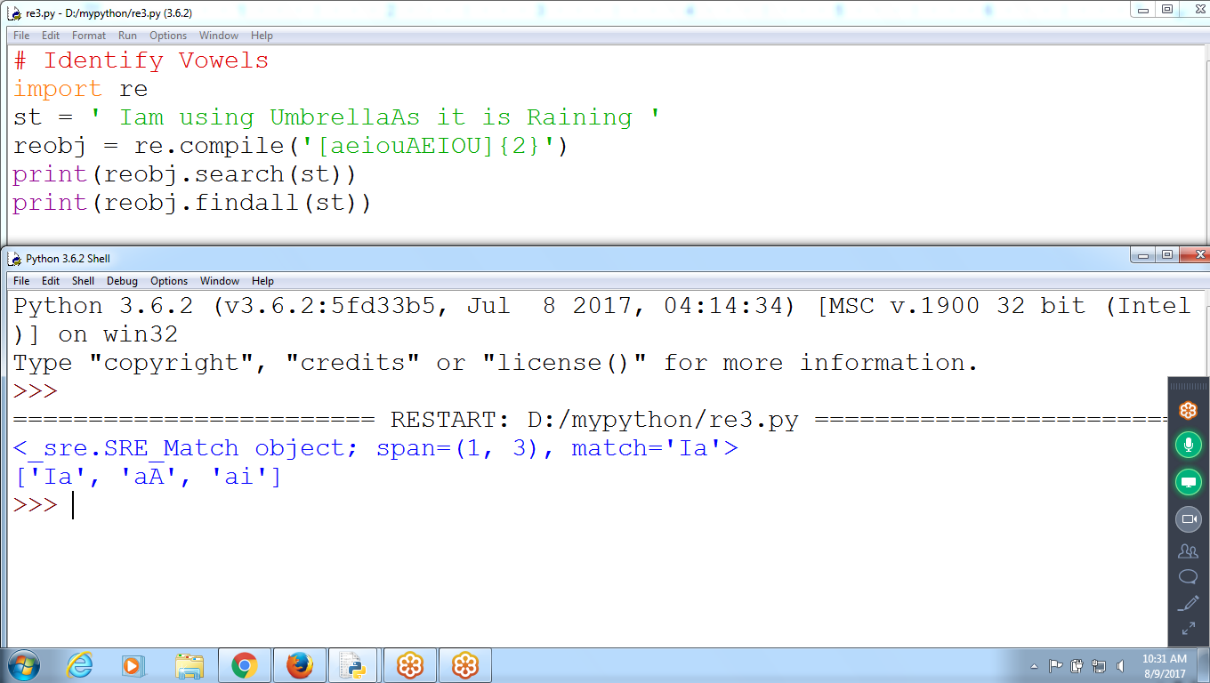

**Checking for consonants**

**^ : Not in between in square bracket**

**# Identify Consonants Caret represents NEGATION**

import re

st = ' Iam using UmbrellaAs it is Raining '

reobj = re.compile('[^aeiouAEIOU]{2}')

print(reobj.search(st))

print(reobj.findall(st))

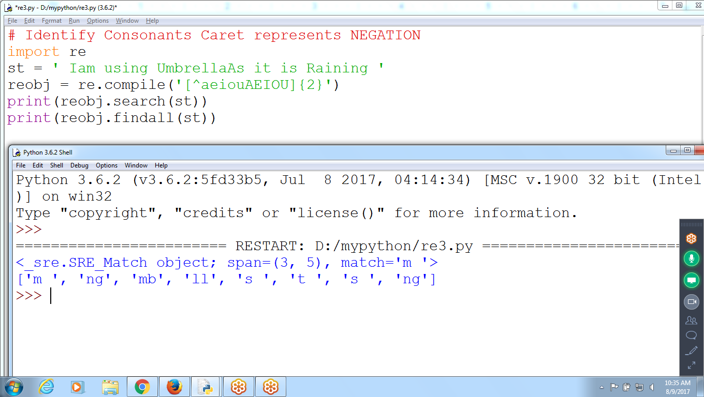

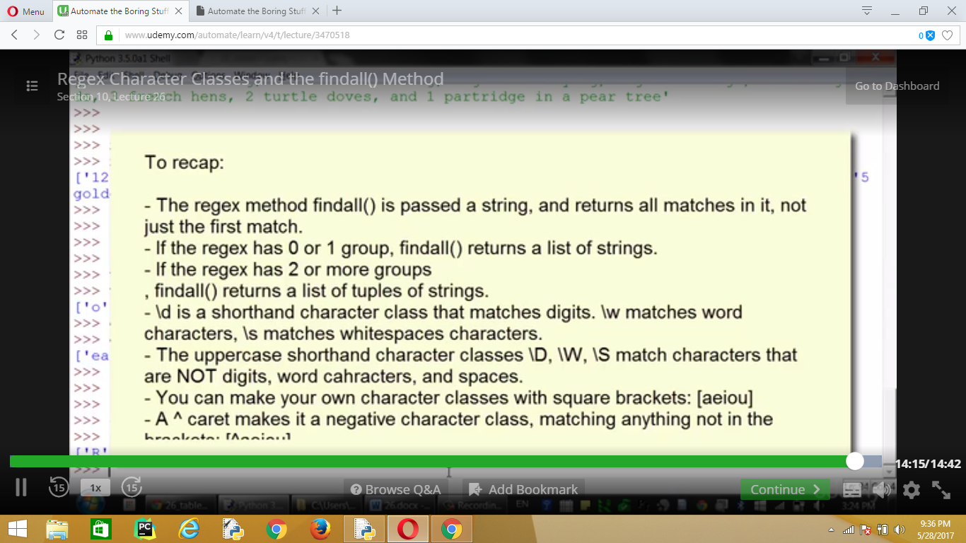

**Regex Dot, star, caret and Dollar**

**^: Starts with**

import re

st = 'Hello Brother'

reobj = re.compile('^Hello')

print(reobj.search(st))

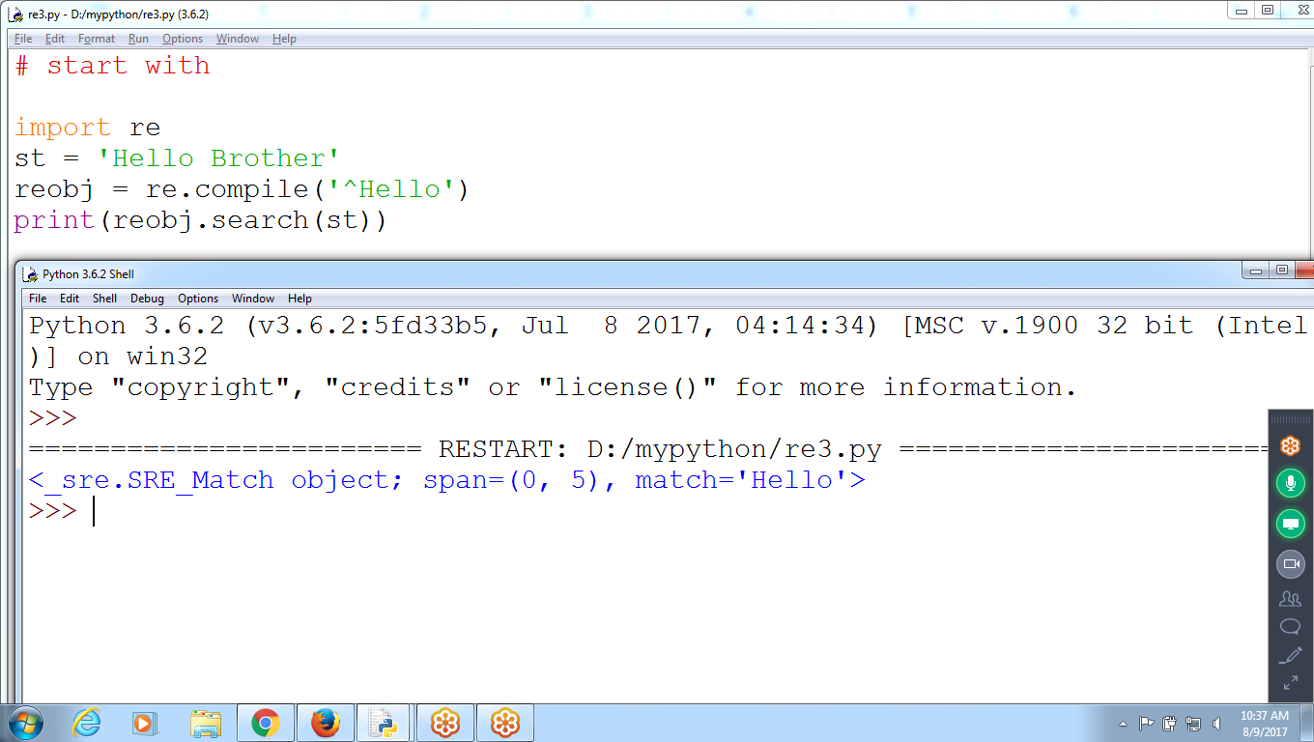

>>> reobj = re.compile(r'^Hello')

>>> reobj.search('Hello Brohter ')

<_sre.SRE_Match object; span=(0, 5), match='Hello'>

>>> reobj.search('hello Brohter "Hello" ')

>>> reobj.search('hello Brohter say Hello.... ')

**$ : Ends with**

>>> re.compile(r'world!$')

re.compile('world!$')

>>> reobj = re.compile(r'world!$')

>>> reobj.search('Hello world!')

<_sre.SRE_Match object; span=(6, 12), match='world!'>

>>> reobj.search('Hello world! I am here')

>>>

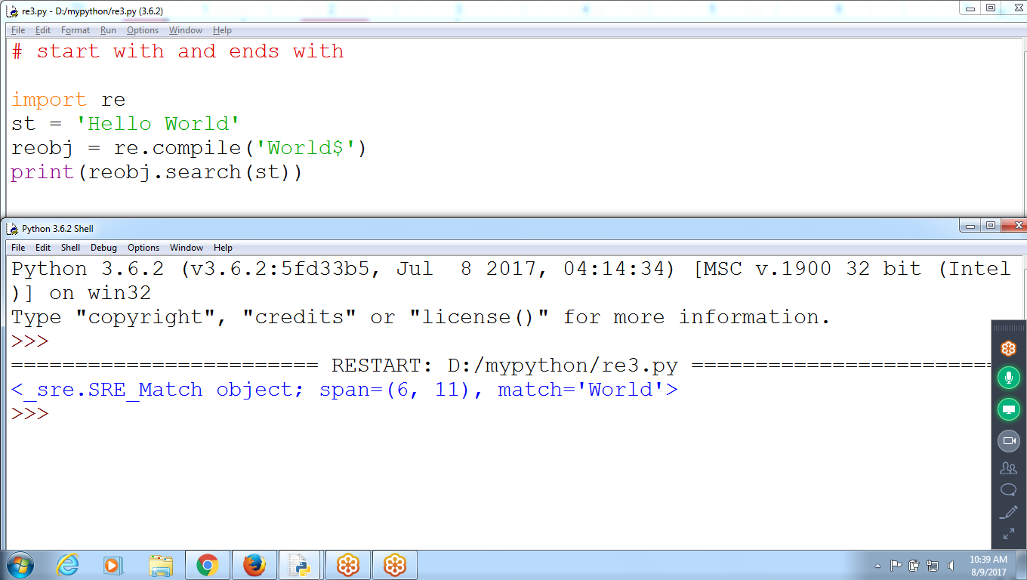

**Starts with Digit and ends with Digit**

>>> reobj = re.compile(r'^\d+$')

>>> reobj.search('123456')

<_sre.SRE_Match object; span=(0, 6), match='123456'>

>>> reobj.search('1234abc8956') == None

True

>>>

reobj = re.compile(r'^\d+\w+\d$')

>>> reobj.search('987abc123')

<_sre.SRE_Match object; span=(0, 9), match='987abc123'>

**. (dot) : Any Single Character without new line**

**import re**

**st = 'Bat Sat on the flat'**

**reobj = re.compile('.at')**

**print(reobj.findall(st))**

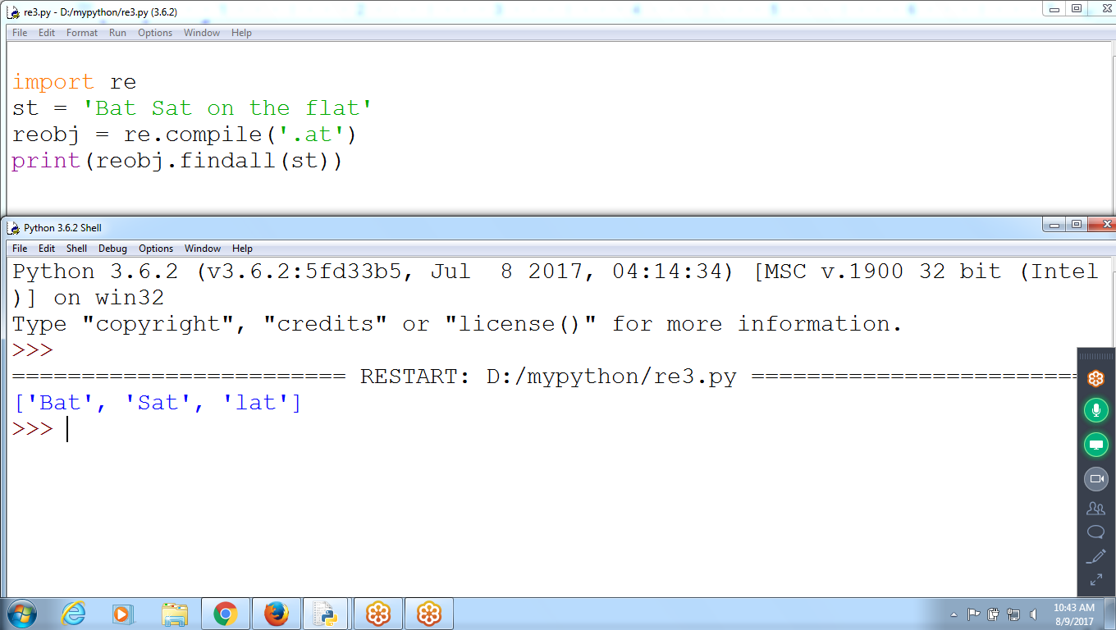

**Any 1 to 3 characters preceding and ends with ‘at’**

>>> reobj = re.compile(r'.{1,3}at')

>>> reobj.findall('The bat sat on the flatmat ')

['e bat', ' sat', ' flat', 'mat']

>>>

**.* ( dotstart )anything**

**Strings after First Name and Last name**

>>> reobj = re.compile(r'First Name: (.*) Last Name: (.*)')

>>> reobj.findall('First Name: Karthik Last Name: Swamy ')

[('Karthik', 'Swamy ')]

>>> reobj.findall('First Name: Karthik Last Name: Swamy First Name: Prem Prakash')

[('Karthik', 'Swamy First Name: Prem Prakash')]

>>>

>>> reobj.findall('First Name: Karthik Las Name: Swamy First Name: Prem Prakash')

[]

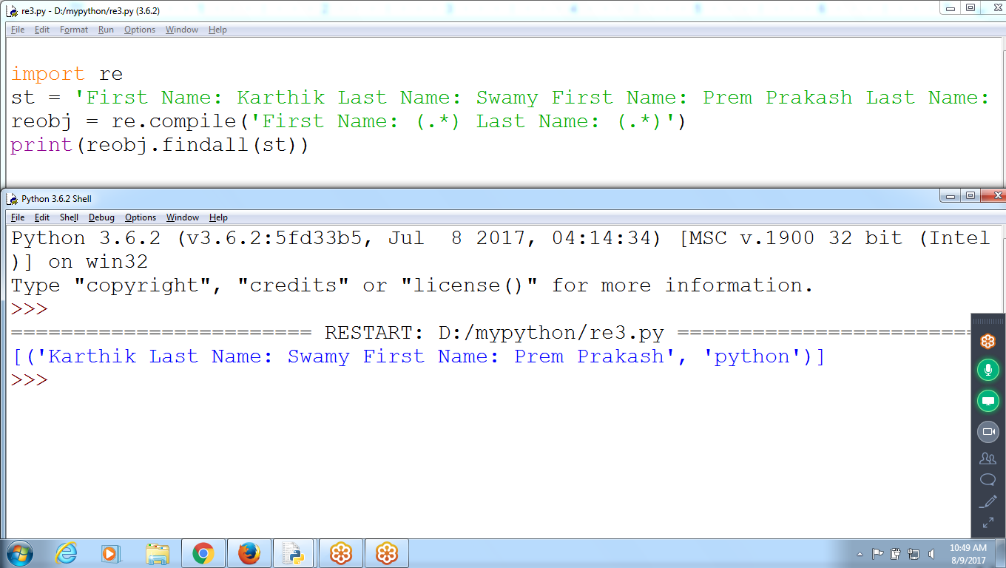

**Ignores Case**

**import re**

**st = 'HI discUssed PYTHON Only'**

**reobj = re.compile('[aeiou]', re.I)**

**print(reobj.findall(st))**

